- Program ID : VQ001MA1

- Display Layout
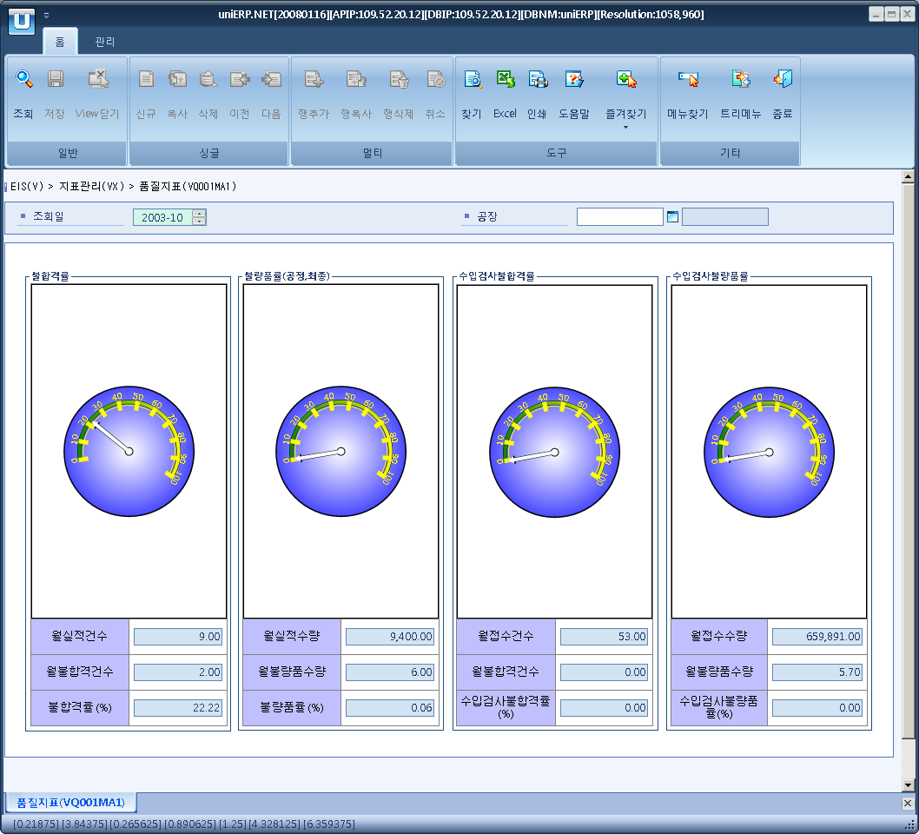

- Event flow
- Click Query button
- OnFncQuery -> DbQuery -> DataChange
- Display Unit combo change
- uniCombo1_ValueChanged -> DataChange

- SQL Statements
- Defective rate
SELECT SUM(VQ0010T.TOT_QTY), SUM(VQ0010T.NOR_QTY), SUM(VQ0010T.RATE)
FROM VQ0010T
WHERE VQ0010T.SP_ID = @strSpId
and VQ0010T.YYYYMM = @strYYYYMM
and VQ0010T.INDEX_CD = 'Q01'

- Defective rate
SELECT SUM(VQ0010T.TOT_QTY), SUM(VQ0010T.NOR_QTY), SUM(VQ0010T.RATE)
FROM VQ0010T
WHERE VQ0010T.SP_ID = @strSpId
AND VQ0010T.YYYYMM = @strYYYYMM
AND VQ0010T.INDEX_CD = 'Q02'

- Incomming Defective rate
SELECT SUM(VQ0010T.TOT_QTY), SUM(VQ0010T.NOR_QTY), SUM(VQ0010T.RATE)
FROM VQ0010T
WHERE VQ0010T.SP_ID = @strSpId
AND VQ0010T.YYYYMM = @strYYYYMM
AND VQ0010T.INDEX_CD = 'Q03'

- Incomming Defective rate
SELECT SUM(VQ0010T.TOT_QTY), SUM(VQ0010T.NOR_QTY), SUM(VQ0010T.RATE)
FROM VQ0010T
WHERE VQ0010T.SP_ID = @strSpId
and VQ0010T.YYYYMM = @strYYYYMM
and VQ0010T.INDEX_CD = 'Q04'

